**Figure 1**

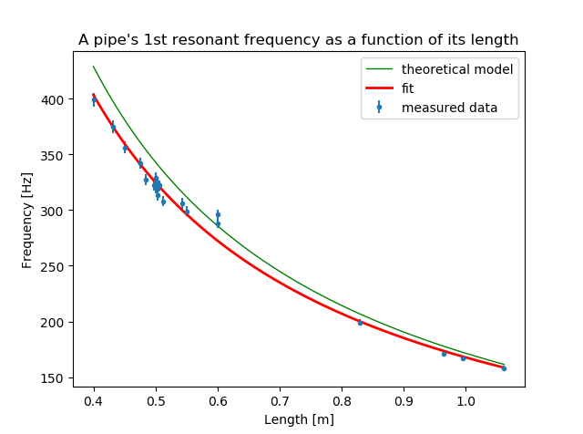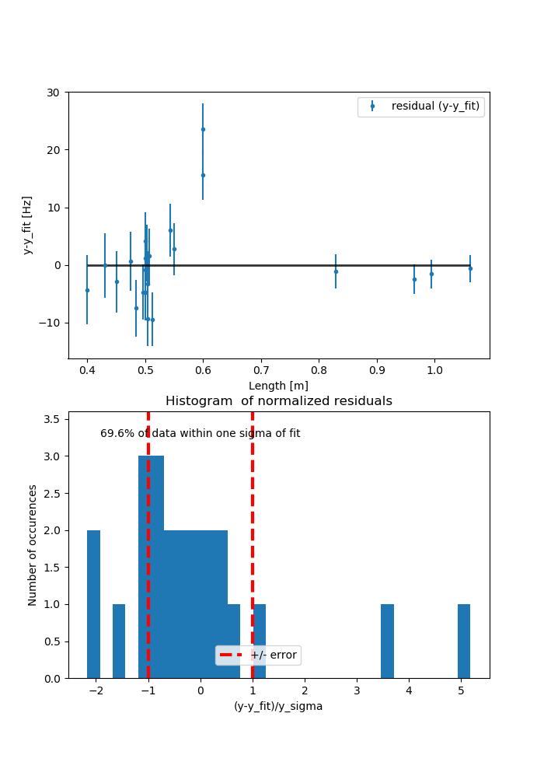

*The figure above is a graph of a pipe’s natural resonant frequency as a function of its length and the data’s residual information that describes the accuracy of the fit. The goal of this experiment was to determine how a pipe’s diameter and length affects the resonant frequenc, and so the data points are natrual frequency measurements of a variety of different length and diameter pipes. The model of this fit was derived to be $f_{n^{th}res}\left(L\right)=\frac{nv_{sound}}{2L}+b$ where n is an integer greater than 0, vsound is the speed of sound, L is the length of the pipe, and b is some vertical offset (n=1, vsound = 3.14*102 +/- 3.428 m/s, b = 1.072*101 +/- 2.826 in our experiment). From the data and model, we can see that the length of the pipe is inversely proportional to the resonant frequency and that the diameter of the pipe has no affect, which is why we are able to graph pipes of varying diameters without worrying that the diameter variable will skew the fit. The residual information shows that I have produced an accurate fit with my model as 69.9% of data within 1 standard deviation resulted in a low calculated Chi2/(degree of freedom) of 2.83.*